**Code Talkers**

**A Project Report**

***submitted in partial fulfillment for the requirements of the award of the degree***

***of***

**BACHELOR OF TECHNOLOGY**

**IN**

**INFORMATION TECHNOLOGY**

**Submitted by**

**KARAN KHIANI (1602913044)**

**RAGHAV SANGAL (1602913077)**

Supervised by

**Ms. ILA KAUSHIK**

(Assistant Professor)



**DEPARTMENT OF INFORMATION TECHNOLOGY**

**KIET GROUP OF INSTITUTIONS, GHAZIABAD, UTTAR PARDESH**

**(Affiliated to Dr. A. P. J. Abdul Kalam Technical University, Lucknow, U.P., India)**

**Session 2019-20**

**DECLARATION**

We declare that

1. the work contained in this report is original and has been done by us under the guidance of our supervisor.
2. the work has not been submitted to any other institute for any degree or diploma.
3. We have followed the guidelines provided by the institute to prepare the report.
4. We have conformed to the norms and guidelines given in the ethical code of conduct of the institute.
5. wherever we have used materials (data, theoretical analysis, figures and text) from other sources, we have given due credit to them by citing them in the text of the report and giving their details in the references.

Signature of the student

Name: Karan Khiani

Roll number: 1602913044

Signature of the student

Name: Raghav Sangal

Roll number: 1602913077

Place: KIET Group of Institutions, Ghaziabad

Date:

**CERTIFICATE**

This is to certify that the project Report entitled, **“Code Talkers”** submitted by **Karan Khiani and Raghav Sangal** in the Department of Information Technology of KIET Group of Institutions, Ghaziabad, affiliated to Dr. A. P. J. Abdul Kalam Technical University, Lucknow, Uttar Pradesh, India, is a record of bonafide project work carried out by them under my supervision and guidance and is worthy of consideration for the award of the degree of Bachelor of Technology in Information Technology of the Institute.

**Signature of Supervisor:**

**Supervisor Name: Ms. Ila Kaushik** (Assistant Professor)

**Date:**

**List of Figures**

|  |  |  |  |
| --- | --- | --- | --- |
| 1.1 | System Environment Analysis | | 2 |
| 3.1 | Feasibility Studies | | 17 |
| 4.1 | SRS Validation | | 20 |
| 4.2 | Approach to Develop System | | 22 |
| 4.3 | Software Development Process | | 23 |
| 4.4 | Prototype Model | | 24 |
| 5.1 | Life cycle Process Model | | 26 |
| 5.2 | ER Diagram | | 27 |
| 6.1 | Context Flow Diagram | | 30 |
| 6.2 | 1 Level DFD |  | 30 |
| 6.3 | 2 Level DFD for Login |  | 31 |
| 6.4 | 2 Level DFD for Chat |  | 31 |
| 8.1 | Home Screen |  | 38 |
| 8.2 | Register Page |  | 39 |
| 8.3 | Login Page |  | 39 |
| 8.4 | Create Task Page |  | 40 |
| 8.5 | Real Time Editor Page |  | 40 |
| 8.6 | About Us Page |  | 41 |
| 8.7 | Contact Us Page |  | 41 |

# LIST OF ABBREVIATIONS

|  |  |
| --- | --- |
| Codet | Code Talkers |
| SQA | Software Quality Assurance |
| SRS | Specification |
| SDD | Software Design Document |
| STP | Software Testing Plan |
| SDLC | Software Life Cycle |
| NFR | Non Functional Requirement |
| DFD | Data Flow Diagram |
| ER | Entity Relationship |
| SQL | Structured query language |
| URL | [Uniform Resource Locator](https://www.myprivatesearch.com/go.php?id=aHR0cDovL3d3dy5tYXN0Z3VydS5jb20vZnVsbC1mb3JtLW9mLXVybC1pcy8zMzg1) |
| GUI | Graphical User Interface |

**ABSTRACT**

This is a project with Node.js. This is a practical project that we can even monetize to companies and businesses. Let us share with you the idea behind this one. In 2019, I met a friend of my father who was an HR to a small company. He shared with me all the pain he and the technical team leader had to go through while hiring developers in their organization. It took them a lot of time and money with agencies to just arrange code testing. Eventually we came up with a solution of online interview together in which the developer team leader will interview the potential candidates and test his coding skills directly over the Internet and in real time.

Thus, this platform named “Codet” was made to meet this ever growing industry demand. This is initially deployed live on Heroku. The platform is made on Node.js. Even better, you can collaborate your code with other person at the same time in chat and by making video call in real time. Express.js, a popular Node.js library is being used to write code. A No SQL database Mongodb is being used for handling data transactions in this application. An Authentication system is also integrated in this application of ours of Facebook and E mail.

It is a perfect example of pair programming and troubleshooting together. This document is the detailed introduction of our project Codet – Code Talkers containing the features and operations performed by our product.

**TABLE OF CONTENTS**

|  |  |  |  |
| --- | --- | --- | --- |
| **1.** | **INTRODUCTION** | | 1 |
| 1.1 Overview of Codet Application | | | 1 |
| 1.2 | Advantages of Codet | | 2 |
| 1.3 | System Environment Analysis | | 2 |
| 1.4 | Theoretical Framework | | 3 |
|  | 1.4.1 | About Node.js | 3 |
|  | 1.4.2 | Overview of Node | 3 |
|  | 1.4.3 | Major Features of Node | 4 |
|  | 1.4.4 | Advantages of Node.js | 4 |
| 1.5 | JavaScript and Its History | | 5 |
|  | 1.5.1 | Overview of Javascript | 5 |
|  | 1.5.2 | Security Features In JavaScript | 6 |

|  |  |  |
| --- | --- | --- |
| 1.6 | About Cloud9 | 6 |
| **2.** | **THE SQA PLAN** | 7 |
| 2.1 | Purpose | 7 |

|  |  |  |  |  |  |  |
| --- | --- | --- | --- | --- | --- | --- |
| 2.2 | Scope |  |  |  |  | 8 |
| 2.3 | Document Overview | |  |  |  | 8 |
| 2.4 | Tasks |  |  |  |  | 9 |
| 2.5 | SQA Implementation | |  |  |  | 9 |
| 2.6 | Documentation | |  |  |  | 10 |
| 2.7 | Document Audit | |  |  |  | 10 |
| 2.8 | Software Development Process | |  |  |  | 11 |
| 2.9 | Project Reviews | |  |  |  | 11 |
| 2.10 Testing and Quality Check | | |  |  |  | 11 |
| **3.** | **SYSTEM ANALYSIS** | |  |  |  | 12 |
| 3.1 | System Analysis | |  |  |  | 12 |
|  | 3.1.1 | Overview of Existing System |  |  |  | 12 |
|  | 3.1.2 | Drawbacks of Existing System |  |  |  | 12 |
|  | 3.1.3 | Overview of Proposed System |  |  |  | 13 |
| 3.2 | Problem Identification | |  |  |  | 13 |
|  | 3.2.1 | Problem Recognition |  |  |  | 14 |
|  | 3.2.2 | Problem Evaluation and Synthesis |  |  |  | 14 |

|  |  |  |  |  |
| --- | --- | --- | --- | --- |
|  | 3.2.3 | Modeling | 14 |  |
| 3.3 | Feasibility | Study | 15 |  |
|  | 3.3.1 | Economic Feasibility | 15 |  |
|  | 3.3.2 | Technical Feasibility | 15 |  |
|  | 3.3.3 | Social attainability | 16 |  |

|  |  |  |  |
| --- | --- | --- | --- |
|  | 3.3.4 Administrative Feasibility |  | 16 |
|  | 3.3.5 Budgetary Feasibility |  | 16 |
|  | 3.3.6 Social Feasibility |  | 16 |
|  | 3.3.7 Security Feasibility |  | 16 |
|  | 3.3.8 Political Feasibility |  | 16 |
|  | 3.3.9 Natural Feasibility |  | 17 |
|  | 3.3.10 Market Feasibility |  | 17 |
| 3.4 | Feasibility Areas |  | 18 |
| 3.5 | Scope of Feasibility Analysis |  | 18 |
| **SOFT**  **4. SPEC** | **WARE REQUIREMENT IFICATION** |  | 19 |
| 4.1 | Overview |  | 19 |
| 4.2 | Modules of Project |  | 21 |
| 4.3 | Functional Requirements |  | 21 |
| 4.4 | Non Functional Requirements |  | 22 |
| 4.5 | Approach to Develop the System |  | 22 |
| 4.6 | Prototyping Model |  | 24 |

|  |  |  |  |  |  |
| --- | --- | --- | --- | --- | --- |
| **5. SYS** | **TEM DESIGN** |  |  |  | 25 |
| 5.1 | Architecture Design |  |  |  | 25 |
| 5.2 | Process Design |  |  |  | 26 |
|  | 5.2.1 V-Model of Development |  |  |  | 26 |
| 5.3 | ER Diagram |  |  |  | 27 |
| 5.4 | Modular Design |  |  |  | 28 |

|  |  |  |  |  |  |
| --- | --- | --- | --- | --- | --- |
| 5.4.1 | Modules of Project |  |  |  | 28 |
| **6. DAT** | **A DESIGN** |  |  |  | 29 |
| 6.1 | Data Flow Diagram |  |  |  | 29 |
| 6.2 | Context Flow Diagram |  |  |  | 30 |
| 6.3 | Data Flow Diagram |  |  |  | 30 |
| 6.4 | Database Design |  |  |  | 31 |
| 6.5 | Standardization |  |  |  | 32 |
| 6.6 | User Interface Design |  |  |  | 32 |
| **7. SYS** | **TEM TESTING** |  |  |  | 34 |
| 7.1 | Test Plan |  |  |  | 34 |
|  | 7.1.1 Test Scripts |  |  |  | 34 |
|  | 7.1.2 Guidelines |  |  |  | 34 |
| 7.2 | System Testing |  |  |  | 34 |
|  | 7.2.1 Unit Testing |  |  |  | 35 |
|  | 7.2.2 Integrated Testing |  |  |  | 36 |

|  |  |  |  |  |  |  |  |
| --- | --- | --- | --- | --- | --- | --- | --- |
|  | 7.2.3 | Framework Testing |  |  |  |  | 36 |
|  | 7.2.4 | Validation Testing |  |  |  |  | 37 |
|  | 7.2.5 | Module Testing |  |  |  |  | 37 |
|  | 7.2.6 | Display Testing |  |  |  |  | 37 |
| **8.** | **SCREENSHOTS** | |  |  |  |  | 39 |
| **9.** | **FUTURE ENHANCEMENT** | |  |  |  |  | 42 |
| **CONCLUSION** | |  |  |  |  |  | 43 |
| **REFERENCE** | |  |  |  |  |  | 44 |

**CHAPTER 1**

**INTRODUCTION**

**1.1 An Overview of our application – Codet (Code Talkers)**

At initial a client needs to enlist and for the enrollment the obligatory fields are Area of intrigue, Name, Email, Mobile no. This application is a stage where you can share or work together your code with the other individual progressively. Likewise you can visit with the video or content to speak with one another over the Internet. The advantage of this undertaking is to give a stage to all coders to team up among themselves, and specialists to test initiates amid F2F testing. The fundamental objective is to set a domain for a coder to write in and watch him/her coding it progressively when he/she is being met remotely or face to face.

This application likewise has worked in video, voice and content visit includes so you're constantly associated with your group from anyplace. This application is explicitly intended for coders to work together through this application through node.js mongodb backend. In balanced visit area you can see name of different friends. So this application is a general bundle for somebody who wishes to employ abilities or work close by your partner. The product being utilized for advancement is Visual Studio Code. This application utilizes MongoDB for tracking the subtleties of the considerable number of clients alongside the spared code bits. This application has been created remembering to give organizations, clients to associate with one another alongside composing on the code editorial manager in a similar time.

**1.2.Advantages of Codet Web Application**

* To inspire the students and hiring managers to build confidence so that they can

enhance their processes.

* Get 1:1 live programming help tailored to you.
* Enhancement of skills with the use of our app.
* Hire world class developers with ease.
* Can be used for mentoring students.
* Can be used for working together on projects in our Codet environment.
* Take advantage of our easiest setup.

**1.3.System Environment Analysis**

* Requirements of hardware
* Processor: 512 MHz processor RAM: 1 GB.
* Disk Space: Not in that capacity.

**Programming Requirements**

* Operating System: Windows/Mac/Linux
* Show: Screen with any measurement and resolution
* Programming : None, Node.js for advancement mode

Figure 1.1 gives us the analysis of the system requirements. The figure is categorized into three sections hardware requirement, software requirement and network requirement.

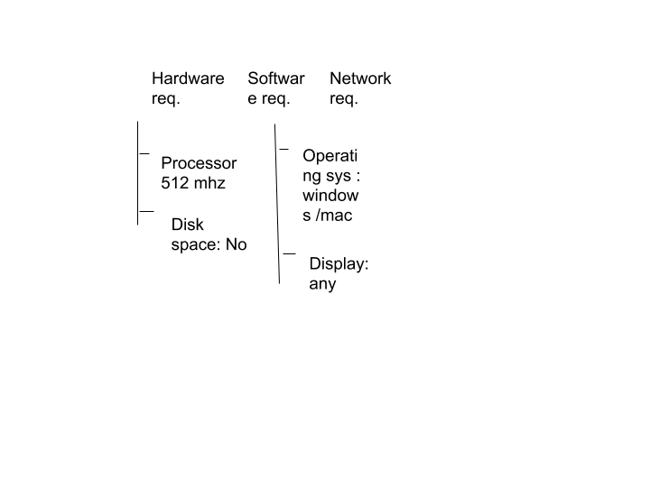 Figure1.1 System Environment Analysis

**1.4.Theoretical Framework**

A theoretical framework is a collection of  inter-related concept. A theoretical framework determines the required things that are used to build the application. The theoretical framework is where you define, discuss and evaluate theories relevant to your research problem

**1.4.1.About Node.js:**

Node.js is cross stage JavaScript runtime condition. It is a well known instrument for practically any sort of task!

A Node.js application is kept running in a solitary procedure, without making another string for each solicitation. Node.js gives nonconcurrent I/O natives in its standard library that anticipate JavaScript code from blocking and libraries in Node.js are composed utilizing non blocking ideal models, making blocking conduct the special case as opposed to the standard.

At the point when Node.js needs to play out an I/O task, such as perusing from the system, getting to a database or the file system, rather than obstructing the string and squandering CPU cycles pausing, Node.js will continue the activities when the reaction returns.

This permits Node.js to deal with a huge number of simultaneous associations with a solitary server without presenting the weight of overseeing string simultaneousness, which could be a critical wellspring of bugs.

Node.js has a special bit of leeway since a huge number of frontend engineers that compose JavaScript for the program are presently ready to compose the server side code notwithstanding the customer side code without the need to become familiar with a totally unique language. In Node.js the new ECMAScript measures can be utilized without issues, as you don't need to trust that every one of your clients will refresh programs – user is the one choosing the ECMAScript.

**1.4.2. Review of Node**

As an offbeat occasion driven JavaScript runtime, it is intended to manufacture adaptable system applications. Node.js (Node) is an advancement stage for executing JavaScript code on the side of server. Hub is valuable for creating applications requiring determined association from program to server and regularly utilized for continuous applications, for example, talk, news sources and web message pop ups.

**1.4.3.Major Features of Node.js**

* + - * **It is asynchronous and event Driven** All APIs of Node.js library are asynchronous, that is, non-blocking.
      * **Super Fast** Being built on Google Chrome’s V8 JavaScript Engine, Node.js is super efficient and quick in code execution.
      * **Single Threaded but Highly Scalable** Node.js uses a single threaded model with event looping. Event mechanism helps the server to respond in a non- blocking way and makes the server highly scalable as opposed to traditional servers like Apache which create limited threads to handle requests.
      * **Optimized graphics** powered by a custom 2D graphics library; 3D graphics based
      * **No Buffering** Node.js applications never buffer any data. These applications simply output the data in chunks.
      * **Media support** for common audio, video, and still image formats (MPEG4,H.264, MP3, AAC, AMR, JPG, PNG, GIF)
      * **GSM Telephony** (hardware dependent)
      * **Bluetooth, EDGE, 3G, and WiFi** (hardware dependent) , **Camera, GPS, compass, and accelerometer** (hardware dependent)

**1.4.4Advantages of Node.js**

* One of the key preferences is that designers think that its simple to scale the applications in even just as the vertical headings. The applications can be scaled in level way by the option of extra hubs to the current framework. Besides, Node.js additionally offers you the choice of adding additional assets to the single hubs amid the vertical scaling of the application. Along these lines, it is exceedingly versatile and gives preferred choice over other JavaScript servers.
* Node.js has been viewed as a full stack JavaScript for serving both the customer and the server side applications. Consequently, the favourable position is that you don't need to contract separate engineers for backend just as the front end advancement. It sets aside both your profitable cash and time.

**1.5 Javascript and its History**

* JavaScript was made by Brendan Eich in 1995 and was the best program made which was delighted in market.
* Microsoft convinced Netscape to react. Initially, they began an institutionalization procedure to avoid Microsoft dealing with the JavaScript language. Second, they joined forces with Sun to use their common enthusiasm for breaking the Microsoft restraining infrastructure.
* Sun started improvement of Java in 1990 trying to compose a language for "keen machines". The methodology was flopped and in 1994.
* So the Netscape/Sun association implied Sun gained the utilization of an aggressive program and a conveyance framework for their vital innovation.
* Netscape, then found a ground breaking partner against Microsoft. They additionally planned to out move Microsoft by being the official program of the exceptionally foreseen stage that was Java.

**1.5.1Overview of Javascript**

JavaScript isn't a programming language in exacting sense. Rather, it is a scripting language since it utilizes the program to do the grimy work. In the event that you order a picture to be supplanted by another one, JavaScript advises the program to go do it. Since the program really takes every necessary step, you just need to pull a few strings by keeping in touch with some generally simple lines of code. That is the thing that makes JavaScript a simple language to begin with.

Be that as it may, don't be tricked by some amateur's karma: JavaScript can be truly troublesome, as well. Above all else, regardless of its straightforward appearance it is an undeniable programming language: it is conceivable to compose very mind boggling programs in JavaScript. This is once in a while fundamental when managing website pages, yet it is conceivable. This implies there are some mind boggling programming structures that you'll just comprehend after extended examinations.

Besides, and all the more critically, there are the program contrasts. Despite the fact that cutting edge internet browsers all help JavaScript, there is no hallowed law that says they should bolster precisely the equivalent JavaScript. An enormous piece of this site is committed to investigating and clarifying these program contrasts and discovering approaches to adapt to them.

**1.5.2 Security Features in Javascript and Node.js**

Since its discharge, there are very few security issues that have increased across the board consideration. The second measure is actualizing a similar birthplace approach, which keeps contents from one site from getting to information that is utilized by contents from different locales. Various JavaScript security vulnerabilities are the consequence of program creators who neglect DOM based JavaScript security dangers.

Starting today, Node.js and its center benefactors keep up a wide range of channels to address the security of the Node.js venture and the security of its clients.

In 2016, at Node.js Interactive in Austin, the Security Working Group was framed, tending to the requirement for a working gathering concentrating on security. It is for the most part in charge of characterizing and keeping up security strategies and techniques for the center Node.js undertaking and different ventures kept up by the Node.js Foundation.

The Security Working Group likewise assists with:

* the Node.js Security task to bring helplessness information into the Foundation,
* review and prescribe forms for treatment of security reports,
* recommend security upgrades for the center Node.js venture,
* facilitate and advance the extension of a solid security administration and item supplier environment vulnerabilities.

**1.6.Overview Of Cloud9 (an AWS IDE Product)**

IDE represents Integrated Development Environment. With the expansion in the unpredictability of programming the IDEs get redesigned or we can say progressively astute.

AWS Cloud9 contains an accumulation of devices that you use to code, construct, run, test, troubleshoot, and discharge programming in the cloud. To work with these instruments, you utilize the AWS Cloud9 incorporated improvement condition, or IDE.

You get to the AWS Cloud9 IDE through an internet browser. The IDE offers a rich code altering background with help for a few programming dialects and runtime debuggers, just as an inherent terminal.

You can design the IDE to your inclinations. You can switch shading topics, tie alternate route keys, empower programming language explicit punctuation shading and code arranging, and then some.

You utilize the AWS Cloud9 IDE, running in an internet browser on your neighborhood PC, to collaborate with your condition. A cloud process occasion (for instance an Amazon EC2 example) or your own server associates with the earth. A domain is where you store your venture's documents and where you run the apparatuses to build up your applications.

You utilize the AWS Cloud9 IDE to work with documents in the earth. You can:

* Store these records locally on the example or server.
* Clone a remote code vault, for example, a repo in AWS Code Commit—into your condition.
* Work with a blend of neighborhood and cloned documents in the earth.

Out of sight, you can train AWS Cloud9 to have Amazon EC2 make an Amazon EC2 occasion and after that interface nature to the recently made example. We consider this kind of setup an EC2 domain. You can likewise teach AWS Cloud9 to associate a situation to a current cloud process occasion or your very own server. We consider this sort of setup a SSH domain.

**CHAPTER2**

**THE SQA PLAN**

**2.1. Reason**

The motivation behind this arrangement s to characterize the ― Codet application Software Quality Assurance (SQA) association, assignments and duties, give reference records and rules to play out the SQA exercises, give the gauges, practices and shows utilized in completing SQA exercises, and give the apparatuses, strategies, and approaches to help SQA exercises, and SQA revealing.

**2.2. Extension**

The motivation behind this arrangement is to characterize the ― Codet application, SQA errands and obligations; give reference records and rules to play out the SQA exercises; give the measures, practices and shows utilized in completing SQA exercises; and give the devices, systems, and approachs to help SQA exercises, and SQA detailing.

This archive has a degree to characterize all methodology, strategies and instruments for using Quality Assurance of our Codet Application. This arrangement:

* It distinguishes the SQA duties of the Application engineer and the SQA specialist.
* It help distinguish work items.

**2.3. Report Overview**

The remainder of the report is composed as pursues:

* Management: It depicts each significant component/individuals of the association.
* Documentation: It helps in the recognizable proof of the records identified with development, check, approval, use and upkeep of our Codet Application
* SQAP Requirements: The SQA survey, revealing, and reviewing methods used to guarantee that product expectations are created as per this plan and the undertaking's prerequisites are characterized under this area.
* Organization Efforts for this application are upheld by number of elements, organizations and people. This device is created as a feature of fractional satisfaction of prerequisites for Bachelors in Computer Applications degree.

**2.4. Assignments**

The assignments performed are as under:

* Development of the necessity particular and cost.
* Development and testing of the application and convey the application alongside the essential documentation.
* A formal introduction to the customer ought to be given on finish of the examination, structure and testing stages. The customer audits the work and gives input/recommendations.
* Planning, planning, testing and surveying all parts of value issues

The duties of the customer are to:

* Review work.
* Provide criticism and counsel.

**2.5. SQA Implementation**

Quality confirmation will be actualized all through Application improvement life cycles of the device's advancement procedure, until the arrival of the product item. Coming up next are the quality affirmation assignments for period of the Application advancement:

* Requirement stage: It must be guaranteed that it clarifies the proposed usefulness of the Application to continue refining the SRS until the prerequisites are obviously comprehended.
* Specification and Design stage: Due to the incredible significance of exactness and fulfillment in these archives, week by week meeting and surveys will be led between the designer and the customer to recognize any deformities and amend them.
* Implementation stage: The engineer will do code audits when the development period of the Application starts.

**2.6. Documentation**

The document will include SRS which:

* Prescribe every one of the basic prerequisites of product
* Verify the culmination of every necessity by a recommended strategy
* Provides office of recognizability of prerequisites detail to Application delivery.
* Gives assessments of the cost/exertion for building up the item including a project plan.
* The SDD.
* Depicts how the product will be organized
* It gives the Description of the different segments and sub parts of the Application configuration, including bundles and systems.
* The fundamental classes are given to article model that would make up the product.
* It gives an example collaboration chart, appearing key communications.
* Software Test Plan: It portrays the experiments, test condition, and so forth., that will be utilized to test the Application.

**2.7. Report Audit**

The audit procedure includes:

* At the finish of every improvement stage (Requirement, Design and mplementation) a formal introduction will be finished.
* A administrative audit by the customer intermittently to guarantee the work done is in Application prerequisites.
* After every introduction audits by the customer is must.

**2.8. Programming Development Process**

The Codet Application advancement procedure will be finished in three phases:

* Necessities stage
* Configuration stage
* Implementation and testing stage

The customer will survey the deliverable archives, amid each stage. The engineer will consolidate changes recommended by the customer. This will guarantee nature of the product item. .

**2.9. Venture Reviews**

The customer will play out an audit at the 3 phases of the venture as portrayed in the segment above. This survey will decide if the necessities have been met, watch that the item meets the prerequisites, check the presentation of the product and guarantee that acknowledgment testing is done. A structure agenda will be utilized and the engineer will verify whether the plan meets the agenda criteria.

**2.10. Testing And Quality Check**

Testing of the application is completed as per STP. Testing documentation will be efficient to show that testing targets and programming requirements are met. The results will be given in the documentation and is talked about in the last period of the task fulfilment.

**CHAPTER 3**

**SYSTEM ANALYSIS**

**3.1.System Analysis**

* System analysis is the process of gathering and interpreting facts and using the facts to improve the system.
* Identifying the drawback.
* Need of conversation.
* Feasibility study
* Identify various requirements.
* Create a system definition.

**3.1.1.Overview of Existing System**

The current contracting and code sharing application like hackerearth and hackerrank is for coding on one framework. It doesn't assist the general population with communicating their issues when coding together. The current application additionally doesn't have the office to speak with specialists in regards to the specific subject's concern.

**3.1.2. Disadvantages of the Existing System**

* There is no visiting highlight.
* There are not many applications like codementor.io which to some degree centers around pair programming.
* Experts talking are additionally not accessible in the current application. They are difficult to utilize.

**3.1.3. Outline of Proposed System**

In the end we concocted an answer of online meeting together in which the engineer group pioneer will meet the potential hopefuls and test his coding abilities straightforwardly over the Internet and progressively.

Hence, this stage named "Codet" was made to meet this consistently developing industry request. This is at first conveyed live on Heroku. The stage is made on Node.js. Stunningly better, you can work together your code with other individual in the meantime in visit and by making video bring progressively. Express.js, a prominent Node.js library is being utilized to compose code. A No SQL database Mongodb is being utilized for dealing with information exchanges in this application. An Authentication framework is likewise coordinated in this utilization of our own of Facebook and E mail.

It is an ideal case of pair programming and investigating together. The essential properties of the proposed framework are as per the following:

* This application UI is extremely easy to utilize.
* It has separate UI for video visit when coding.
* The proposed framework has dialog talk framework while you're coding.
* We can talk about the relate issue through coordinated visit and numerous to one moreover.
* Less multifaceted nature and less diversion.

**3.2. Issue Identification**

Necessity examination is the product building task that conquers any hindrance between framework level prerequisite building and programming plan. Programming prerequisite examination is isolated into three:

* Problem Recognition
* Problem Evaluation and Synthesis
* Modeling

**3.2.1. Issue Recognition**

The primary objective of the issue acknowledgment is the acknowledgment of the essential issues as seen by the clients. The current framework is wasteful when contrasted and the proposed framework. In the current framework there isn't much understudy explicit Applications with every one of the highlights accessible at one spot. The proposed framework gives every one of the highlights at one spot. The proposed framework is planned with spotlight on understudies. In the current framework there are not many applications that give a portion of the highlights of the proposed framework yet it's UI is excessively intricate, Keeping understudies as a top priority a straightforward UI is grown so it is understudy neighborly.

**3.2.2. Issue Evaluation and Synthesis**

In the issue assessment and union the product designer must characterize all remotely detectable information objects, and show extra plan requirements. Every one of these assignments serves to depict the issue with the goal that a general arrangement might be blended.

The Proposed framework has been produced for the present necessities, which is invaluable over the current framework. Here the application is planned with spotlight on understudies and its UI is straightforward and easy to understand.

**3.2.3. Demonstrating**

Amid programming prerequisites investigation, we make models of it to be worked to increase better comprehension of the genuine coherent substances (capacities and sub capacities) to be manufactured. Coming up next are the jobs of models in necessities examination.

* The model encourages investigator to get data, capacity, and behaviour of the framework
* The model turns into the principle reference for survey to decide completeness, consistency and exactness of the determination.
* The model turns into the establishment for plan.

**3.3. Plausibility Study**

The credibility of an assignment can be discovered similar to specific components, money related components, or both. In endeavour cash, the pre financing work (now and again insinuated as due assurance) is to guarantee there is no "dry ruin" in the errand and to recognize undertaking threats ensuring the management after discovering "commitment organization" limit.

Believability is an extent of how invaluable the improvement of the information structure will be to an affiliation. This is done by investigating the present structure suggestion as demonstrated by its usefulness, influence on the affiliation, ability to address customer issues, and reasonable use of advantages.

Hardly any key examinations are related with the reachability examination: financial, specific and social, etc.

**3.3.1. Financial Feasibility:**

Financial examination is the most habitually utilized strategy for assessing the viability of a framework. Cost related with the improvement of computer frameworks is as per the following.

* Procurement costs, for example, interview, hardware buy, establishment, outfitting the size and so forth.
* Start up costs, client working framework cost, individual inquiry cost and so on. Venture related costs, for example, programming buy, preparing work force, data collection, reports readiness costs and so forth.
* On going costs, for example, equipment, programming support, rental, devaluation of equipment costs and so on.

**3.3.2. Specialized Feasibility:**

In analysing Technical possibility of the framework, mineral significance is given to the equipment communication part of the framework. The evaluations of specialized achievability focuses on the current framework and to what degree it can bolster the proposed expansion. This depended on a layout structure of framework prerequisites in turns of sources of info, documents projects, strategies and staff. It includes budgetary contemplations to suit specialized upgrades. The propose framework has three level design comprising of firebase as the database, and Application Server as firebase as the centre level.

**3.3.3. Social attainability:**

PC establishments are related with turnover, moves and changes in employment status. The presentation of a competitor framework requires uncommon exertion to teach, sell and train the staff. The programming is structured to such an extent that no one but people can get to it having android portable and an individual with some PC information can cooperate with the framework unreservedly. PC unskilled individuals require preparing for efficient use of the software.

**3.3.4. Administrative Feasibility:**

Administrative attainability includes the capacity of the foundation of a procedure to accomplish and support process improvement. The executives support, worker inclusion, and responsibility are key components required to find out administrative plausibility.

**3.3.5. Budgetary Feasibility**

Budgetary plausibility ought to be recognized from monetary practicality. Venture financing can be a noteworthy snag in huge multi party ventures as a result of the dimension of capital required. Advance accessibility, credit value, value, and advance calendar are significant parts of monetary plausibility examination.

**3.3.6. Social Feasibility:**

Social achievability manages the similarity of the proposed undertaking with the social setup of the task condition. In labour escalated ventures, arranged capacities must be coordinated with social practices such as each one utilizing portable so it is socially achievable.

**3.3.7. Security Feasibility:**

Security possibility is another significant viewpoint that ought to be considered in task arranging. Lamentably, ecological effect appraisal is frequently not satisfactorily tended to in complex activities. For instance, the North American Free Trade Agreement (NAFTA) between the U.S. and Canada were suspended in 1993 on account of the legitimate thought of the natural effects of the activities to be embraced under the agreement.

**3.3.8. Political Feasibility:**

A politically possible venture might be alluded to as a "politically right undertaking." Political contemplations frequently manage course for a proposed task. This is especially valid for enormous activities with national perceivability that may have noteworthy government inputs and political ramifications. For instance, political need might be a wellspring of help for a venture paying little heed to the undertaking's benefits. Then again, commendable tasks may confront unconquerable restriction essentially as a result of political variables. Political possibility investigation requires an assessment of the similarity of venture objectives with the common objectives of the political framework.

**3.3.9. Natural Feasibility:**

Frequently an enemy of undertakings through long, drawn out endorsement forms and altogether dynamic resistance by those guaranteeing ecological concerns. After a ton of assets and endeavours, Disney couldn't conquer the nearby resistance to the ecological effect that the Disney task would have on the noteworthy Manassas battleground zone.

**3.3.10. Market Feasibility:**

The market needs investigation to see the potential effects of market request, focused exercises, and so on and "divertible" piece of the overall industry accessible. Value war exercises by contenders, regardless of whether neighbourhood, territorial, national or universal, should likewise be investigated for early possibility financing and obligation administration dealings amid the start up, increase, and business start up periods of the task.

Figure 3.1 depicts the categorization of feasibility studies.

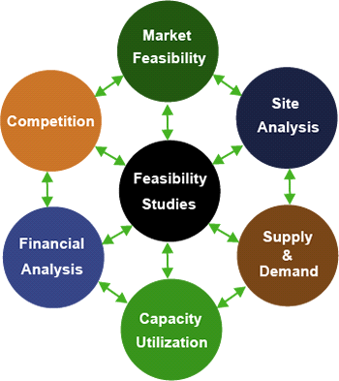

Figure3.1 Feasibility Studies

**3.4. Feasibility Areas**

The Feasibility Study is the primer examination that decides if a proposed frameworks venture is in fact, monetarily. The Alternatives Analysis, generally included as a major aspect of the Feasibility Study, distinguishes practical choices for the framework structure and advancement. The records give: An examination of the framework destinations, practical necessities, and framework plan ideas:

* A assurance of the achievability of applying mechanized frameworks to viably, productively, and monetarily improve program tasks;
* An assessment of elective methodologies for sensibly accomplishing the destinations and objectives; and
* Identification of a proposed methodology

**CHAPTER 4**

**SOFTWARE REQUIREMENT SPECIFICATION**

**4.1. Overview**

An exact and careful comprehension of framework prerequisites is fundamental to the achievement of any SDP. Every single further phase of SDLC like framework investigation, plan and coding rely upon how exact solid and steady and altogether comprehended the System Requirements Specification is. Ineffectively examined prerequisites will disillusion the client regardless of how very much planned and the all around coded the product is. Prerequisite detail seems, by all accounts, to be a moderately basic errand however the odds of error is high, equivocalness is plausible and correspondence hole among client and designer will undoubtedly bring perplexities. Necessity Specifications start with an unmistakable and compact heading expressing in a libe the errand (for example work objective). For this, we need to distinguish the issue first. Issue determinations fill in as the reason for distinguishing work target that aides in portraying the necessities in specialized and exact articulations. After the underlying particular reports are gotten, they are broke down and refined through client designer association. Framework Analysis pursues to decide plausibility.

A total comprehension of prerequisite determination of framework is significant for the fruitful advancement of the product item. Prerequisite particular is the establishment during the time spent programming improvement. All further advancement like System Analysis, Framework Design will depend upon how precise and solid and steady the prerequisites.

By and large Description

* Prerequisite determination gives off an impression of being generally basic undertaking, yet appearances are regularly misdirecting. There is dependably an opportunity of wrong particular in view of correspondence hole among client and engineer, equivocalness in prerequisite or a wrongly indicated issue.
* Prerequisite Specification starts with an unmistakable proclamation of the issue and the errand to be performed. At that point necessities are depicted in a specialized way in exact articulations. After the underlying particular reports are gotten, they are investigated and refined through client engineer association. Framework Analysis pursues to decide and money saving advantage investigation.

Figure 4.1 depicts the stages for a validated SRS. The stages are repeated and validated given with the problem given and the product achieved.

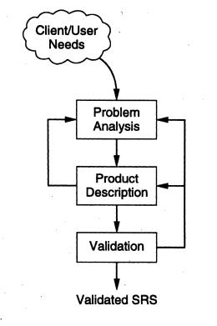

Figure4.1 SRS Validation

The SRS is often referred to as the "parent" document because all subsequent project management documents, such as design specifications, statements of work, software architecture specifications, testing and validation plans, and documentation plans, are related to it.

Its imperative that a SRS contains practical and non useful necessities just; it doesn't offer plan recommendations, potential answers for innovation or business issues, or some other data other than what the improvement group. It comprises following stages

**4.2.Modules of the Project**

* Text Chat Window: Integrated window chat where two users can interact with text message.
* Code Editor: A text area where two users can write code at the same time.
* Video Call Window: Video and voice calling feature is also embedded such as to make more interaction between two users.
* Login/Register: A new user can create their own profile and login with their credentials. This feature maintains the authenticity of the website.
* Create New Task: The user can create their unique task and share their unique task id such that to connect with another user.

**4.3. Practical Requirements**

* The application ought to have the option to store the client subtleties in the database (MongoDB).
* There will be one sign in strategy utilizing username and secret key.
* There will be an alternative of visit where you can talk and get help from others.
* A pop up message is to be send to the clients whom the message will be send in talk.
* When the notice is gotten to by the client, the talk screen will be opened.
* On the season of information exchange client will almost certainly make a record for code altering.
* There is two way talking it is possible that coordinated or gathering visit.

**4.4. Non Functional Requirements**

* Execution Requirements
* The essential execution prerequisite is speed of the system to join the application.
* Wellbeing Requirements
* There are no wellbeing necessities for this application.
* Programming Quality Attributes

The essential trait of this application will be ease of use given the a lot of information and data that will be displayed on such a little screen, just as the client's capacity to include information into the gadget in a sensible way that ought not be significantly more troublesome than if they were at a genuine PC. As ease of use is difficult to evaluate,

Generous client testing will be required and criticism accumulated so as to decide whether the application can commonly be viewed as usable.

Since this application will be on a telephone. We don't need it to occupy so much room or be too moderate making the client's not have the option to fit it on the gadget.

**4.5.Approach To Develop The System**

**System/Information** **Engineering**

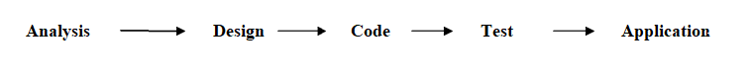

Figure4.2 Approach to Develop the system

The model perspective begins with essential get together. Improvement and customer meet and portray the general objectives for the item, perceive whatever essentials are known, and format districts where further definition is required. A lively design‖ occurs.

The lively structure revolves around a depiction of those pieces of the item that will be clear to the customer/customer. The lively arrangement prompts the improvement of a model. The model is evaluated by the customer/customer.

Iteration occurs as the model is to satisfy the necessities of the customer, while meanwhile enabling the architect to all the more promptly appreciate what ought to be done.

After arrangement stage is supported, we seek after the immediate model to develop the all out structure. After structure organize we move to coding.

The originators use this model to reefing the essentials and set up the last assurance document. Since the working model has been surveyed by the customer.

It is kept an eye on by the customer. Conventionally, this overview offers contribution to the fashioners that clears vulnerabilities in the necessities of the item, and starts an accentuation of refinement.

The model being made isn't the last thing to be passed on and the code created in the model is being escape anyway the experience amassed from structure up the model assistants in structure up the genuine system. The architects should make model as on schedule as possible to quicken the item improvement process.

In figure 4.3 the process steps of developing a software is described.

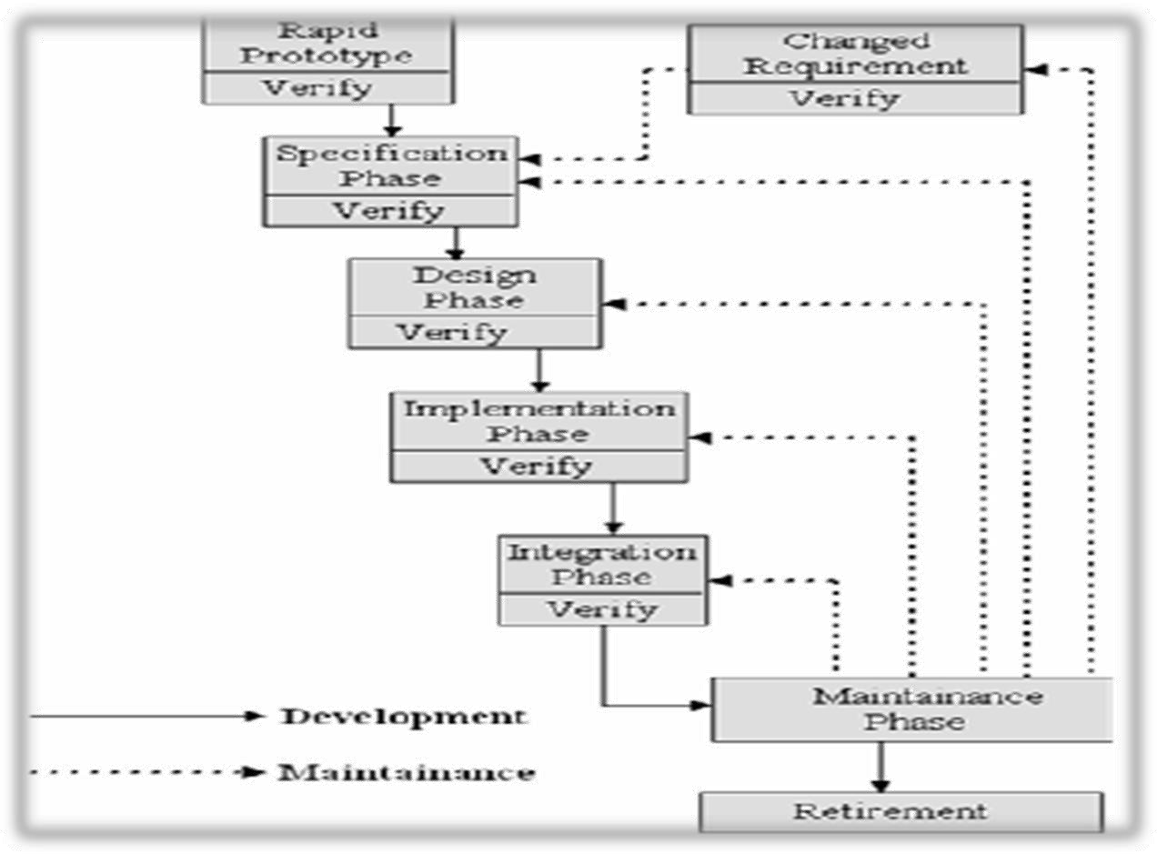

Figure 4.3- Software Development Process

**4.6.Prototyping Model**

Prototyping model is the model of software development life cycle where the Iterative process starts with a simple implementation of the software requirements and iteratively enhances the evolving versions until the full system is implemented.

Figure 4.4 describes the working of Prototype model with various stages.

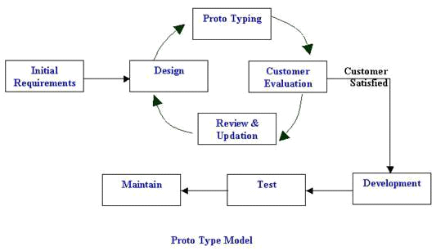

Figure 4.4 Prototype Model

**CHAPTER 5**

**SYSTEM DESIGN**

**5.1.Architecture Design**

It gives understanding and essential detail to execution of the framework which is the most significant. Accentuation is on the presentation prerequisites into structure particulars. The Design stage is required to be check by the client or we can say that it will be according to the client necessity. (Framework proposition) to a reported situated to the software engineers or database staff.

Highlight of Three level Architecture:

Ithas the or this product has three level design. The division of the application empowers quick plan of the framework and improvement of the framework. The measured plan makes it simpler to make changes to only one level without influencing the others framework. Isolating the capacities into unmistakable levels makes it simpler to screen and upgrade the presentation of each layer. Burden adjusting and including greater limit can happen autonomously at each layer. Multi level engineering additionally makes it less complex to gauge the framework over numerous processors on various machines.

Three level design presents a server between the customer and the server. Manifolds is the job of operator. It can give administration of interpretation (as in adjusting a heritage application on a centralized server to a customer/server condition), metering administrations (as in going about as an exchange screen to restrain the quantity of concurrent solicitation to a given server), or keen operator administrations (as in mapping a solicitation to various servers, grouping the outcomes and returning a single.

* The introduction layer conveys the application to end clients on the web.
* The business rationale layer keeps up guidelines that run the application.
* The database deals with the information required by the application.

**5.2. Procedure Design**

**Procedure design** is the process of designing the elements of a system such as the architecture, modules and components, the different interfaces of those components and the data that goes through that system.

**5.2.1. V – Model of improvement**

V model sdlc Process is an entire process. This sdlc must be connected at each phase in the product procedure.

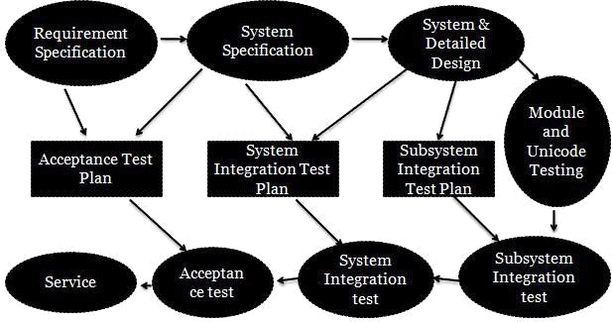

Figure 5.1 Life cycle Process Model

The **V Model** (Figure 5.1 Lifecycle Process Model ) programming improvement life cycle directs the framework procedure advancement and the upkeep and adjustment of frameworks.

This standard accomplishes the accompanying targets: Improvement and certification of the quality. The revelation of deformities in a framework.

* The checking of the framework whether it works or not in the operational circumstance.
* The result ought to be finished in institutionalized procedure to keep up the parity.
* Defined break results make testing or evaluation of the framework extremely simple. Uniform item substance mitigate the comprehensibility of the items and the evaluation systems.
* To compute the expense for the entire life cycle.
* To rearrange the appraisal and testing and to keep up the standard so the framework can turn into the more straightforward.
* This institutionalized technique makes the cost figuring increasingly straightforward precise and simple. Any dangers regarding the expenses can be perceived better.
* Uniform principles lessen erosion misfortunes among purchaser and chief just as between lead director and subcontractor.
* Standardized techniques take into account the decrease in the utilization of assets.
* In instance of an institutionalized technique general ways to deal with the arrangements become straightforward.
* The interval results/last outcomes are institutionalized to such a degree, that different gatherings included or staff of different organizations can settle in without especially exertion, if essential.

**5.3. ER Diagram**

In Figure 5.2

* **Rectangle**: Represents Entity sets.
* **Ellipses**: Attributes
* **Diamonds**: Relationship Set
* **Lines**: They link attributes to Entity Sets and Entity sets to Relationship Set

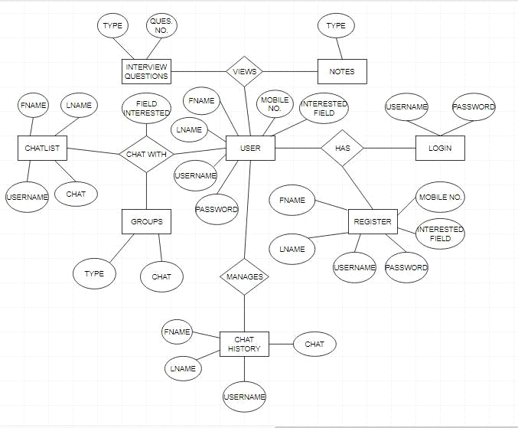

Figure5.2 ER Diagram

**5.4.Modular design**

This task contains numerous modules. Be that as it may, this is one of the most recent node.js applications, which is expanding fame alongside the understudy sort of utilization. It is made for web stage and it is versatile so we can utilize it for any perusing gadget.

It depends on single fundamental usefulness. Simply start up the application and it promptly begins giving you a code manager with modules of video and content talk. There is no compelling reason to characterize something individual. We are getting information from the mongodb database. All your code is being spared time to time in it. In the wake of getting, the putting away of information in to databases occurred, with the goal that we could increase the performance.

**Modules of the venture**

* Login/Register
* Create New Task
* Text Chat Window
* Video call tab
* Code Editor

**CHAPTER 6**

**DATA DESIGN**

**6.1. Data Flow Diagram**

Information Flow Diagrams speak to a standout amongst the most significant apparatuses utilized for structure necessity and investigation. It has the method for determining framework prerequisite and testing significant change that will move toward becoming projects in framework structure. It is the real begin point in the planning stage that practically separates into the prerequisites particular to the most minimal dimension of subtleties. A framework capacities separates into the necessities particular to the most reduced dimension of subtleties. it is DFD comprises of a progression of air pocket joined by lines. The air pocket or speck speaks to information change and line speaks to information stream in the framework.



1. Square, that defined the source or destination of data

* Square, source or destination.



II. Arrow that shows the data flow.

The DFD at the straightforward dimension is referred DFD. They expands level by level each term clarifying its procedure in the detail. Procedures are numbered for simple distinguishing proof and are typically marked in square letters. Every datum stream is named for simple comprehension.

**6.2.Context Flow Diagram**

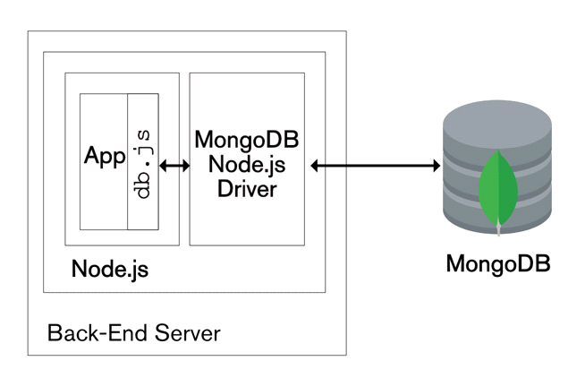

Figure6.1 Context Flow Diagram

**6.3. Data Flow Diagram**

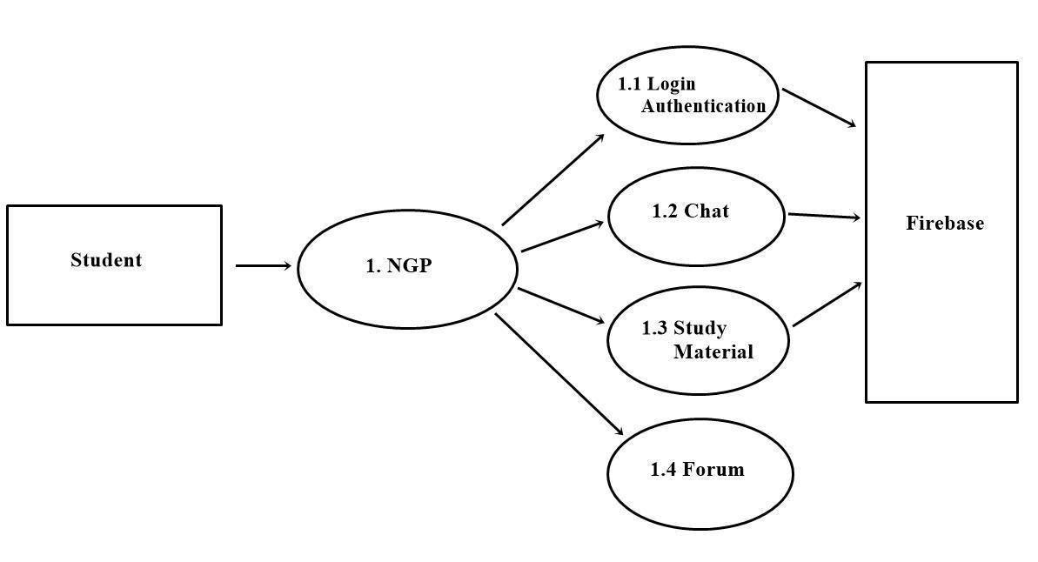 Figure6.2 LEVEL 1 DFD

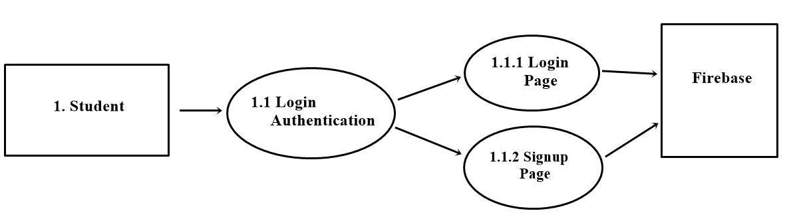

Figure6.3 LEVEL 2 DFD for Login

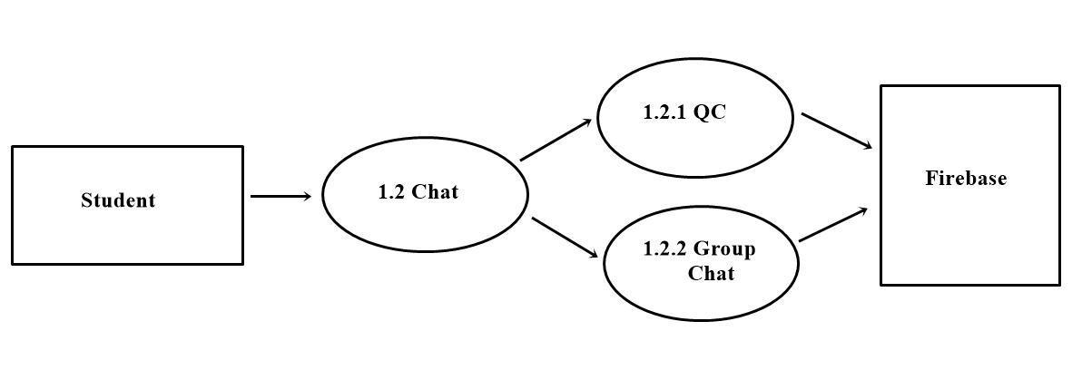

Figure 6.4 – LEVEL 2 DFD FOR Chat

**6.4.** **Database Design**

Information in PC is named a database. There is programming that enables at leastone people to utilize and/adjust this information is a database the board framework (DBMS). A noteworthy job of the DBMS is to enable the client to manage the information in theoretical terms, as opposed to as the PC stores the information. The DBMS meets as a mediator for an abnormal state programming language; in a perfect world enabling the client to indicate what must be finished with almost no consideration on the client's part to the itemized calculation or information portrayal utilized by the framework. One approach to get a field for the various parts of the DBMS is to consider the different sorts of clients of such a framework and ways they collaborate with the framework and with one another.

In social database approach, information is sorted out in sensible scientific sets in forbidden structure. The information filled turns into record turns into a column in a table. Connection between different table zones is characterized using a numerical capacity, for example, JOIN and UNION. The cost significant points of interest of social model are its adaptability in portraying the connection between the different information things.

The most significant part of structure of utilization. The information put away in a table must be sorted out in a few way, which is significant. The general goal during the time spent table configuration has been to accomplish three noteworthy destinations are given underneath:

●Data Integration

●Data Integrity

●Data Independence

A few degrees of standardization must be connected amid the procedure of table structure. The real point of the procedure of standardization is to decrease information excess and counteract losing information honesty. Excess alludes to undesirable and pointless reiteration of information. Information trustworthiness needs to change over at all dimensions. Poor standardization can cause issues identified with capacity and recovery of information. Amid the procedure of standardization, conditions can be recognized which cause difficult issue amid erasure and refreshing. Normalizing likewise help in rearranging the structure of table.

Standardization gives a table streamlining through the enquire of substance connections. Principle reason for standardization is to disregard Data repetition and some unexpected adaptability factors. Standardization is done to evacuate Insertion,

Refreshing and Modification irregularities and repetition of information. A specific dimension of standardization of tables based of points of interest steps pursued. Database will be standardized up to a characterized ordinary structures as indicated by the necessity of utilization and its effectiveness.

**6.5. Standardization**

The database is in fnf as every one of the fields of all tables are nuclear. There is no multi esteemed field in any table.

The database is in snf as it fulfils the requirement of full practical reliance. Every one of the fields of all tables are completely practical reliant on the essential key.

The database is in tnf as the entirety of its tables fulfil the imperative that there should be no transitive reliance. No field has transitive reliance on the key field. In this manner database likewise fulfils the limitations of third typical structure.

**6.6. UI Design**

The interface configuration depicts how the product will imparts inside itself, to framework that between works with it UI is the entryway into the intuitive programming application. the framework what move is to be made for entering, changing, or recovering information. It ought to enable clients to achieve preparing move is to be made for entering, changing or recovering information. The interface will be so that it incorporates strategies that won't not be right or unsatisfactory to visit clients who become families with the framework, however it will encourage similarly compelling use by tenderfoot clients. It ought to avoid any activity that will make a handling mistake.

Interface configuration centres around:

* The structure of interfaces between programming segments
* The structure of interfaces among programming and other non human makers and buyers of data

**CHAPTER 7**

**SYSTEM TESTING**

**7.1.** **Test Plan**

Test Plan depicts the testing procedure and way to deal with testing. QA is to approve the nature of the item before discharge. It likewise contains different assets required for the fruitful consummation of this undertaking.

**7.1.1. TEST SCRIPTS**

A test content is a lot of guidelines that executes a test suite of experiments.

The objectives of a test content are to computerize or record the accompanying:

* execution of experiments.
* relapse testing.

The help these objectives, the destinations of a solitary test content include:

* Report the consequence of the test suite.

A test content gives the accompanying advantages:

* It supporting relapse testing.
* Failure to create test contents makes relapse testing less inclined to happen and increasingly costly.

**7.1.2. Guidelines**

Three test contents will be utilized at all dimensions of testing.

if the nature of the test contents isn't in any event tantamount to the nature of the thing under test to know whether the deformity causing the disappointment of the tests, which are recorded in the related test reports.

**7.2*.*** **System Testing**

Testing is the phase of executing, which is gone for procuring framework running precisely and effectively. The motivation behind the framework testing is to distinguish and address mistakes in the new framework. The exhibition components like turnaround time, back up, record insurance and human variables are a portion of the presentation criteria for framework testing. A framework is tried for online reaction, show, recuperation from disappointment and ease of use.

Framework testing is intended to reveal shortcomings that are not found in the prior tests. This incorporates constrained framework disappointment and approval of the all out framework, as its clients in the operational condition will actualize it. Framework testing includes unit testing, reconciliation testing, acknowledgment testing.

A test plan has the accompanying advances:

* Prepare test plan
* Specify conditions
* Prepare test information
* Prepare test information
* Plan client preparing
* Compile/amass programs
* Prepare work execution helps.

The framework on an entire was tried for the accompanying:

Speed of information bringing from firebase:

* holding tests
* Consistency

Framework testing, asks an intelligent supposition that if every one of the pieces of the framework are right, the framework will be effectively accomplished. To satisfy these targets a progression of tests were arranged and executed. The coherent structure and the physical plan ought to be altogether and constantly analysed on paper to guarantee affirmation that all is right

**7.2.1.Unit Testing**

Here, every program was tried utilizing the test information. The yields according to the prerequisites were discovered tasteful. Along these lines it was conceivable to infer that each program in the product was practically right.

* Affirm that data streams appropriately and put of the program under test.
* Information structures are inspected to affirm that information put away incidentally keeps up its honesty amid calculation execution.
* All show is checked to affirm that it is good for all android gadgets.
* All autonomous ways are executed in any event once to affirm that the each module is executed at any rate once.
* Error taking care of ways are additionally tried.

A testing centres around the check exertion on the littlest unit of the product plan. Utilizing the unit test plan arranged in the structure period of the framework, significant control ways be tried to reveal the mistakes inside these modules.

**7.2.2. Incorporated Testing**

This framework was approved so that even the smallest deviation in contributing the information will summon mistake messages and give rules in regards to the info. Before the product is being discharged, the designers to do testing by executing the business security bundle for security.

This guarantees the product works appropriately. These tests can likewise be performed

* Top down incorporation
* Bottom up incorporation

All modules are joined in this testing step, and the whole program is tried all in all. In the event that a lot of mistakes are experienced remedy is troublesome on the grounds that the separation of causes is convoluted by inconceivability of the whole program.

Utilizing incorporated framework test plan arranged in the structure period of the framework created as a guide, he mix was conveyed up.

**7.2.3. Framework Testing**

At the point when a framework is created, it is trusted that it performs appropriately. Practically speaking anyway a few mistakes dependably happen.

The principle destinations of framework testing are:

* To guarantee amid activity the framework will execute according to details.
* To ensure that the framework meets client's necessities amid activity.
* To check that the controls fused in the framework work as expected.
* To see that when right data sources are nourished to the framework the yields are right.
* To ensure that amid task inaccurate information and yield will be show mistake message.

**7.2.4. Validation Testing**

Validation testing is done to guarantee total get together of the blunder free programming. Approval can be named effective just on the off chance that it capacities in way that is sensibly expected by the client.

Under approval is alpha and beta testing. Alpha testing is the place the end client tests the framework as opposed to the engineer, however in a controlled situation. The product is utilized on a characteristic setting with the designer observing the client utilizing the framework. The engineer records the mistakes and utilization issues experienced by the client.

The initial phase in framework testing is to build up an arrangement that tests every one of the parts of the framework. Framework testing is most valuable functional procedure of executing a program with of discovering mistakes that causes the program to fall flat.

**7.2.5. Module Testing**

Every individual projects module is tried for any potential blunders. They were additionally tried for determinations, for example to see whether they are filling in according to what the program ought to do and how it ought to perform under different conditions.

**7.2.6. Show Testing**

The showcase systems were tried since the showed is of generally significance. The information was contribution to the various modules and it was checked whether the data is appropriately shown in the other ward modules. The consistency of the showcase and engaging quality of the presentation were likewise tried. The accompanying tests were additionally directed over the framework created:

* These test the incorporation among programs and servers, applications and information, equipment and programming.
* These test the general ease of use of a site page or a web application, including appearance lucidity and route.
* These test the ampleness and exactness of the security controls.

**CHAPTER 8**

**PROJECT SCREENSHOTS**

The home page (figure 8.1) of web application which contains the short description of features of website

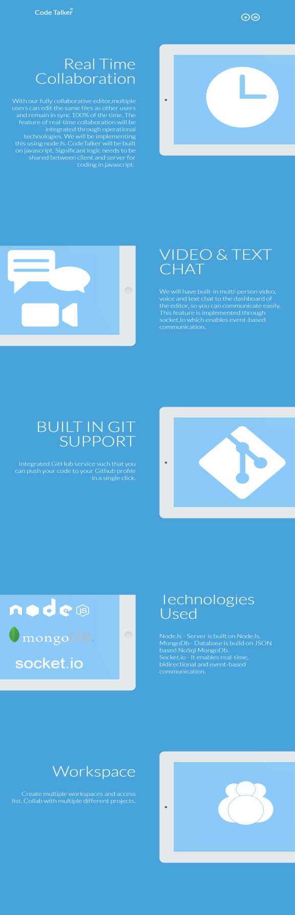

Figure 8.1 Home Screen

In figure 8.2 a new user can register to website with unique username and unique email id with their suitable password. Passwords are stored in database in encrypted form.

Figure 8.2 Register Page

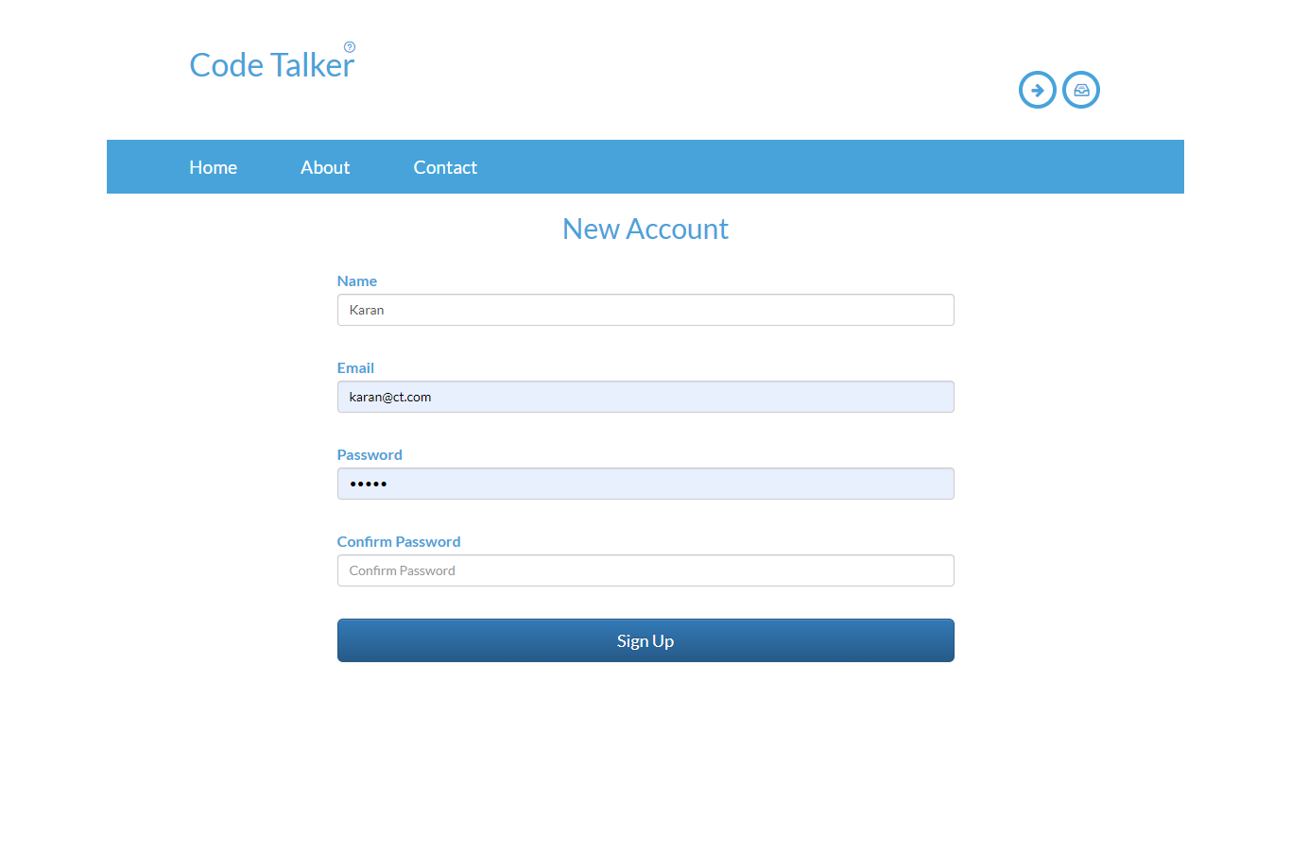

In figure 8.3 a registered user can login with their credentials to the website.

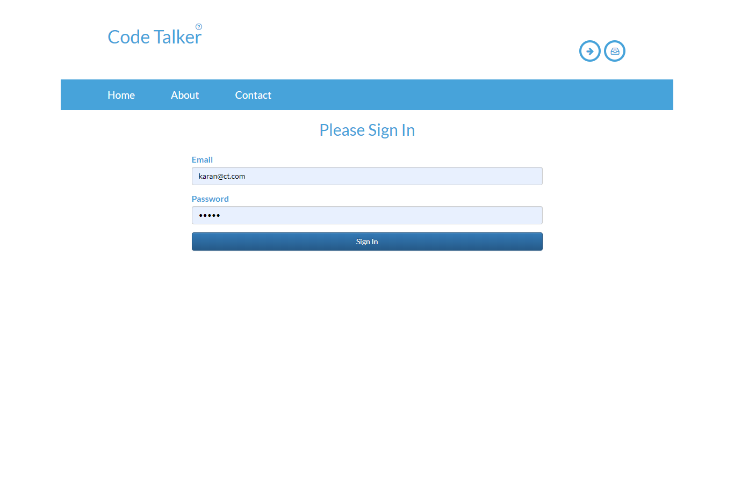

Figure 8.3 Login Page

After successful login by the user the welcome screen in figure 8.4 as depicted where it shows the name of the user with the logout button and a navigation bar. The home section has create task button to create a unique task id that can be shared with other user and both the users can code at the same time.

Figure 8.4 Create Task Page

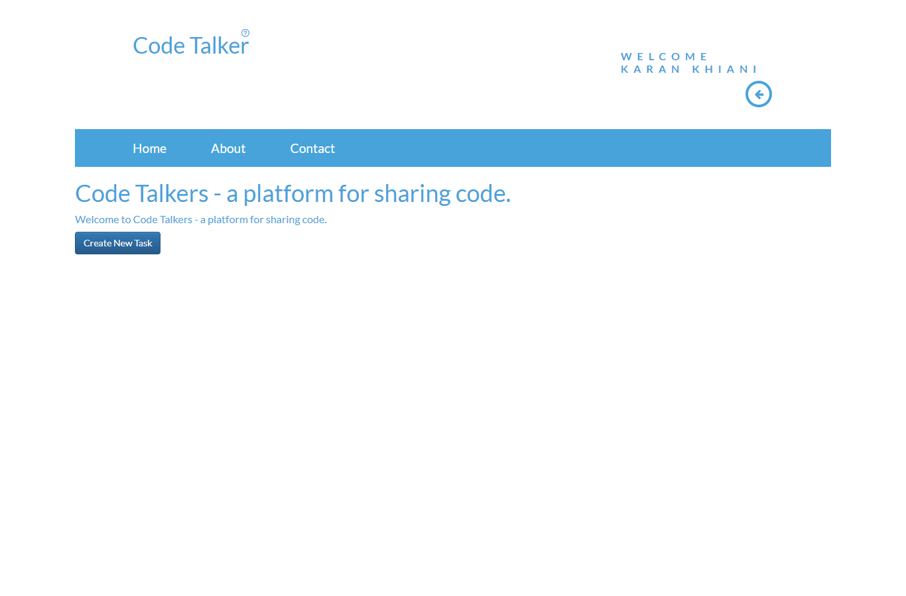

The left section of figure 8.5 consists of a real-time editor where multiple users can work at the same time. The right upper section has a video calling feature which shows you user id that can be shared with other user. The right bottom section contains a chat feature where users can text message to each other.

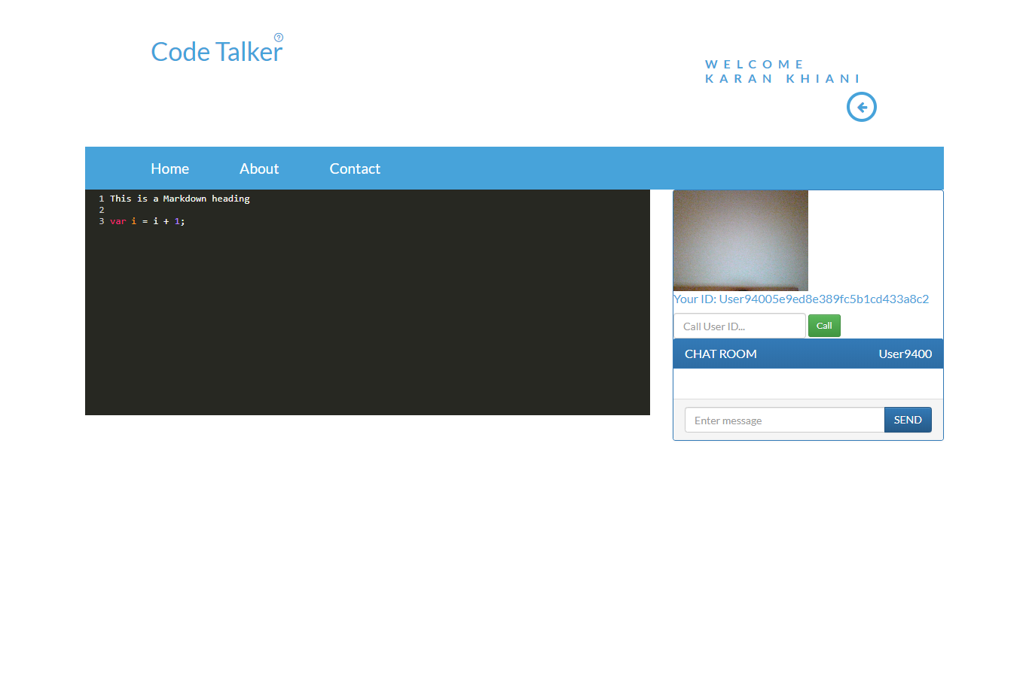

Figure 8.5 Real Time Editor with Video Calling and Chatting Feature

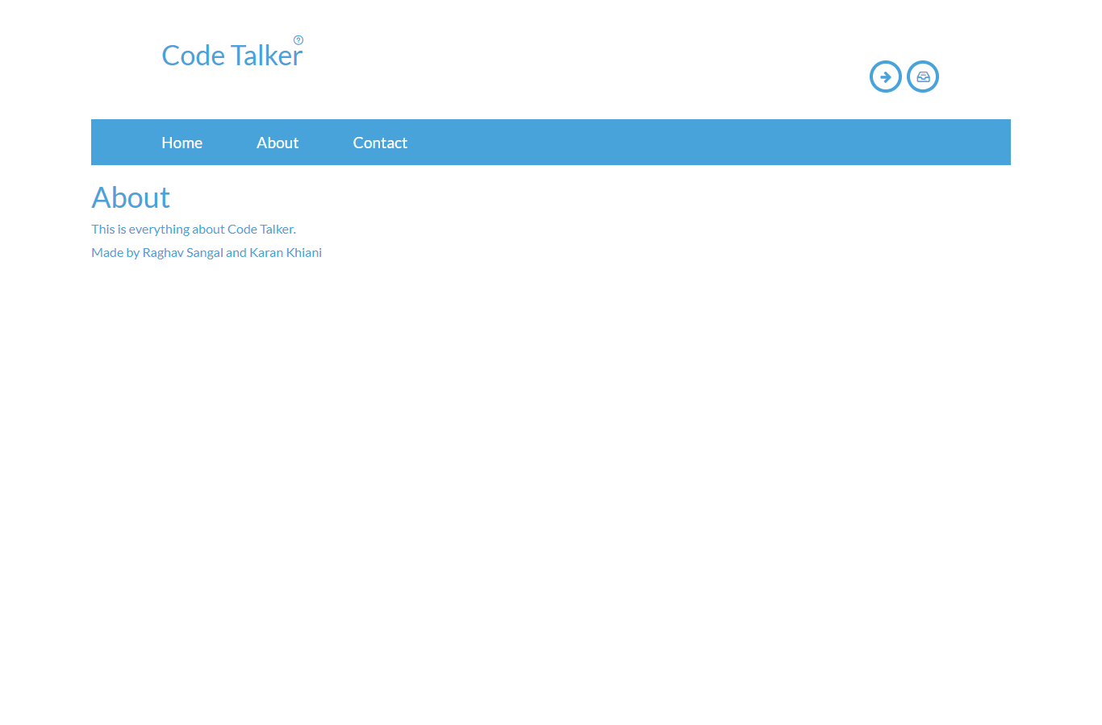

Figure 8.6 About Us Page

Figure 8.7 is a feedback or suggestion page on the website where the submitted data reaches on the developers email.

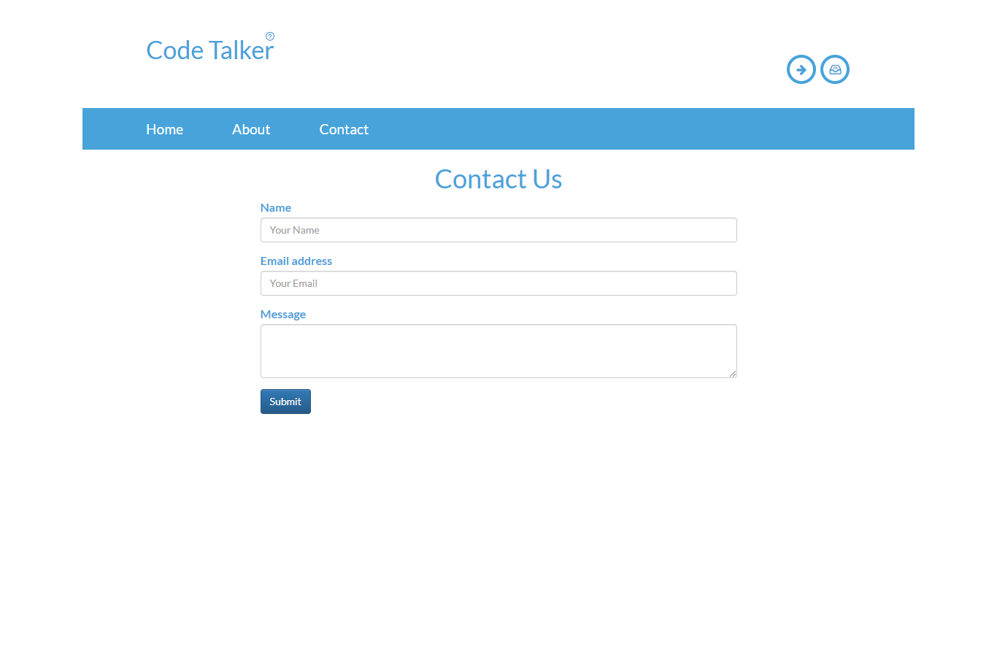

Figure 8.7 Contact us

**CHAPTER 9**

**FUTURE ENHANCEMENT**

I. We will move the database from MongoDB to our mLab for online DB.

II. In future we will give usefulness of Github coordinating to github.com.

III. IIn Future We will get more clients communicate in one session.

IV. We will give the Image sending office in talk area

V. We will furnish substitute login choice like Login with Google and G.

VI. Shortening of User Id into one of a kind identifiers.

VII. In Quick talk there will be choice for connection for reports.

**CONCLUSION**

**CODET CodeTalkers** is an easy to understand intelligent Application for programs and requires no earlier information of programming. Every one of the recommendations sent amid the product proposition have been effectively finished and last edge of utilization has been crossed.

A few mistakes were spotted out amid the framework testing and were rectified. You may experience difficulties not secured by the book, as undertaking is unique so it goes easily and enables you to keep away from regular traps that application ventures utilizing a redistributed engineer can experience.

**REFERENCES**

* <https://www.androidhive.info/>
* [https://developers.google.com](https://developers.google.com/)
* [https://www.tutorialspoint.com](https://www.tutorialspoint.com/)
* <https://www.mongodb.com/>
* <https://www.simplifiedcoding.net/>
* <https://in.udacity.com/>

[https://stackoverflow.com](https://stackoverflow.com/)/